System Requirements

Analysis Model

System Design Model

Program Code

Vertification Report

Analysis Phase

System Design Phase

Implementation

Vertification Phase

* Project GUI part is creating by JavaFX
* There are buttons for the access in user interface model.

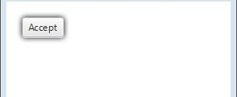

* Search bar to find what you have saved.

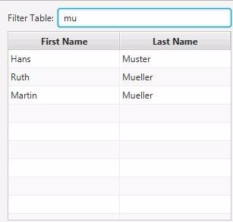

* I will use combo box, especially on date entries.

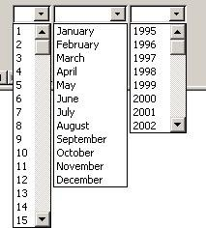

Mustafa Ozan GÜNEY

20160602093